Attachment Workshop for PCIT Therapists

ONLINE TRAINING

June 21, 22, and 23, 2021

Beth Troutman, PhD, ABPP

University of Iowa Carver College of Medicine
Iowa City, Iowa

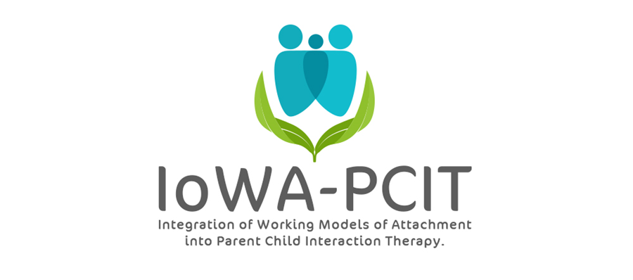

Description of training: This workshop will introduce PCIT therapists to the research-based methods of assessing attachment that inform IoWA-PCIT (Integration of Working models of Attachment into PCIT). Participants will learn how to use observations of attachment to improve their PCIT coaching. Following the training, participants are eligible to be recognized as an IoWA-PCIT therapist.
About the trainer: Beth Troutman, Ph.D., ABPP has more than 35 years research, clinical, and training experience in infant and early childhood mental health. Dr. Troutman is the founder and creator of IoWA-PCIT, an adaptation of PCIT that incorporates attachment and behavioral principles to improve parent-child interactions and reduce disruptive behavior. Dr. Troutman’s research on attachment, infant mental health, and IoWA-PCIT has been published in peer-reviewed journals and presented at national and international meetings. Her book, Integrating Behaviorism and Attachment Theory in Parent Coaching, published by Springer in 2015, has been widely read by researchers and mental health providers. The Korean translation of this book was published by HAKIJSA in 2019.

Attachment for PCIT Therapists Workshop

ONLINE

PLEASE PRINT LEGIBLY—THANK YOU!
Name:
Credentials (e.g. LISW, LMHC, MSW, PhD):
Organization:
Address:
City: State: Zip:
Day Phone: Fax:
Email:
REGISTRATION FEE: $750 per person | PAYMENT
- Includes:  - 3 all day sessions (10 to 5 CST) on June 21, 22, & 23, 2021  - Integrating Behaviorism and Attachment Theory in Parent Coaching book | - Registration is complete when form and fees are received. Refunds will not be available for registered participants.  - Mail registration and payment (check or money order) to:  ATTN: Beth Troutman  1-182 Medical Education Building  Psychiatry Research  University of Iowa Carver College of Medicine  Iowa City, IA 52242-1057  - Check payable to:  University of Iowa
ONLINE TRAINING
All meetings will be held via ZOOM. ZOOM link will be provided following registration.
For questions contact Beth Troutman: beth-troutman@uiowa.edu
CEUS
Documentation of hours of attendance will be available. Full time is intended to meet the criteria for 15 hours of continuing education for Behavioral Science; Psychology; and Social Work.

