IoWA-PCIT Training Part I and II

April 24 to 28, 2023 (Part I)
September 20 to 22, 2023 (Part II)

University of Iowa Carver College of Medicine
Iowa City, Iowa

Beth Troutman, PhD, ABPP

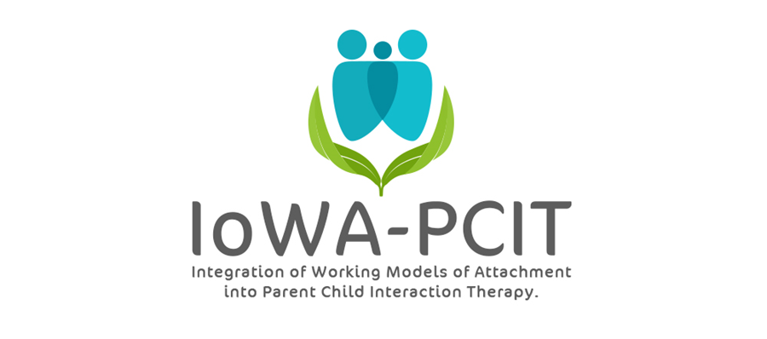

Description of training: This year long training provides mental health providers with the training and consultation needed to deliver IoWA-PCIT. Providers learn: 1) to administer and interpret standardized assessments of parent-child interaction based on attachment and behavioral principles; 2) to administer and interpret standardized assessments of disruptive behavior; 3) to coach parents in Child-Directed Interaction (CDI) and Parent-Directed Interaction (PDI). Providers begin delivering IoWA-PCIT following Part l training (April 24 to 28, 2023). Monthly consultation calls and Part ll training (September 20 to 22, 2023) provide support for implementation of IoWA-PCIT and tailoring coaching based on attachment, presenting problem, and other aspects of patient population.

About the trainer: Beth Troutman, Ph.D., ABPP has more than 35 years research, clinical, and training experience in infant and early childhood mental health. She has been providing PCIT training through the training and research program for PCIT at the University of Iowa since 2009. Dr. Troutman’s training in attachment theory includes training in evidence-based attachment assessments and interventions at the University of Iowa, the University of Minnesota, the University of Amsterdam, the University of Quebec at Montreal, Tulane University, and Marycliff Institute. Her research on attachment and infant mental health has been published in peer-reviewed developmental and clinical journals and presented at national and international meetings.

IoWA-PCIT Training Part l and ll
University of Iowa Carver College of Medicine
Psychiatry Research
Medical Education Building
Iowa City, IA 52242-1057
PLEASE PRINT LEGIBLY—THANK YOU!
Name:
Credentials (e.g. LISW, LMHC, MSW, PhD):
Organization:
Address:
City: State: Zip:
Day Phone: Fax:
Email:
REGISTRATION FEE: $4000 per person | PAYMENT
- Includes:  - 5 all day sessions on April 24, 25, 25, 27, and 28, 2023; 3 all day sessions on September 20, 21, and 22, 2023; monthly consultation calls from September, 2023 through September, 2024  - IoWA-PCIT manual  - Conference registration fees do not include lunch, accommodations, or parking. Arrangements for hotel accommodations are the responsibility of each individual participant. | - Registration is complete when form and fees are received. Refunds will not be available for registered participants.  - Mail registration and payment (check or money order) to:  ATTN: Beth Troutman  1-182 Medical Education Building  Psychiatry Research  University of Iowa Carver College of Medicine  Iowa City, IA 52242-1057  - Check payable to:  University of Iowa
MEETING LOCATION
All meetings will be held at the Medical Education Building at the University of Iowa.
For questions contact Beth Troutman: 319-384-3236; beth-troutman@uiowa.edu
CEUS
Documentation of hours of attendance will be available. Full time attendance for the 5 day session (part l) is intended to meet the criteria for 30 hours of continuing education for Behavioral Science; Psychology; and Social Work. Full time attendance for the 3 day session (part ll) is intended to meet the criteria for 18 hours of continuing education. Full Sign-up sheets and information will be available on site.

