IoWA-PCIT Training Part I and II

February 26 to March 1, 2024 (Part I)
May 15 to 17, 2024 (Part II)

University of Iowa Carver College of Medicine
Iowa City, Iowa

Beth Troutman, PhD, ABPP, ECMH-E®
Kelly Pelzel, PhD

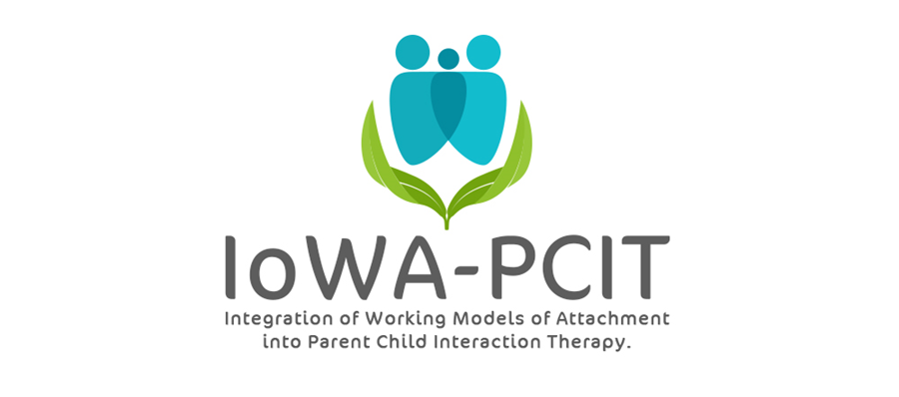

Description of training: This year long training provides mental health providers with the training and consultation needed to deliver IoWA-PCIT. Providers learn: 1) to administer and interpret standardized assessments of parent-child interaction based on attachment and behavioral principles; 2) to administer and interpret standardized assessments of disruptive behavior; 3) to coach parents in Child-Directed Interaction (CDI) and Parent-Directed Interaction (PDI). Providers begin delivering IoWA-PCIT following Part l training (February 26 to March 1, 2024). Monthly consultation calls and Part ll training (May 15 to 17, 2024) provide support for implementation of IoWA-PCIT and tailoring coaching based on attachment, presenting problem, and other aspects of patient population.

About the trainers: Beth Troutman, Ph.D., ABPP, ECMH-E® has more than 35 years research, clinical, and training experience in infant and early childhood mental health. She has been providing PCIT training through the training and research program for PCIT at the University of Iowa since 2009. Dr. Troutman’s training in attachment theory includes training in evidence-based attachment assessments and interventions at the University of Iowa, the University of Minnesota, the University of Amsterdam, the University of Quebec at Montreal, Tulane University, and Marycliff Institute. Her research on attachment and infant mental health has been published in peer-reviewed developmental and clinical journals and presented at national and international meetings.

Kelly Pelzel, Ph.D. received her undergraduate degree from the University of Northern Iowa and her doctoral degree from the University of Utah. She is a licensed psychologist who provides assessment and therapy services to children and their families. Assessment specialties are early childhood mental health and autism spectrum disorder. Her therapy services include IoWA-PCIT and Project ImPACT. Dr. Pelzel is also a Certified Trainer Consultant for Project ImPACT and a past president of the Iowa Association for Infant and Early Childhood Mental Health.

IoWA-PCIT Training Part l and ll
University of Iowa Carver College of Medicine
Psychiatry Research
Medical Education Building
Iowa City, IA 52242-1057
PLEASE PRINT LEGIBLY—THANK YOU!
Name:
Credentials (e.g. LISW, LMHC, MSW, PhD):
Organization:
Address:
City: State: Zip:
Day Phone: Fax:
Email:
REGISTRATION FEE: $4000 per person | PAYMENT
- Includes:  - 5 all day sessions on February 26, 27, 28, 29, and March 1, 2024; 3 all day sessions on May 15, 16, and 17, 2024; monthly consultation calls from March, 2024 through March, 2025  - IoWA-PCIT manual  - Conference registration fees do not include lunch, accommodations, or parking. Arrangements for hotel accommodations are the responsibility of each individual participant. | - Registration is complete when form and fees are received. Refunds will not be available for registered participants.  - Mail registration and payment (check or money order) to:  ATTN: Beth Troutman  1-182 Medical Education Building  Psychiatry Research  University of Iowa Carver College of Medicine  Iowa City, IA 52242-1057  - Check payable to:  University of Iowa
MEETING LOCATION
All meetings will be held at the Medical Education Building at the University of Iowa.
For questions contact Beth Troutman: 319-384-3236; beth-troutman@uiowa.edu
CEUS
Documentation of hours of attendance will be available. Full time attendance for the 5 day session (part l) is intended to meet the criteria for 30 hours of continuing education for Behavioral Science; Psychology; and Social Work. Full time attendance for the 3 day session (part ll) is intended to meet the criteria for 18 hours of continuing education. Full Sign-up sheets and information will be available on site.

