IoWA-PCIT Training Part I and II

ONLINE TRAINING

July 19 to 23, 2021 (Part I)
January 24 to 26, 2022 (Part II)

Beth Troutman, PhD, ABPP
University of Iowa Carver College of Medicine
Iowa City, Iowa

Tracy Vozar, PhD, IMH-E® (IV-R/F)
University of Denver Graduate School of Professional Psychology
Denver, Colorado

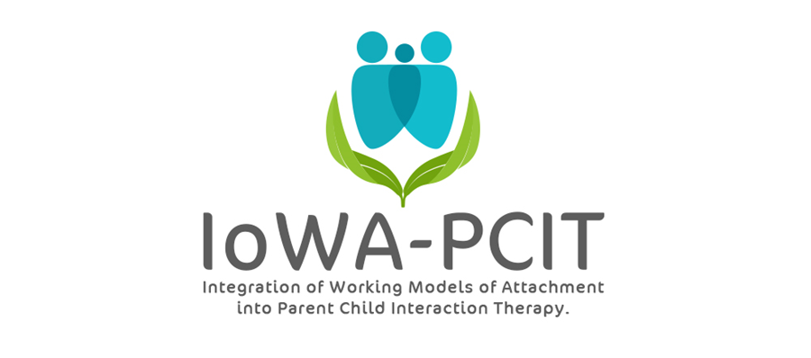
Description of training: This year long training provides mental health providers with the training and consultation needed to deliver IoWA-PCIT. Providers learn: 1) to administer and interpret standardized assessments of parent-child interaction based on attachment and behavioral principles; 2) to administer and interpret standardized assessments of disruptive behavior; 3) to coach parents in Child-Directed Interaction (CDI) and Parent-Directed Interaction (PDI). Providers begin delivering IoWA-PCIT following Part l training (July 19 to 23, 2021). Monthly consultation calls and Part ll training (January 24 to 26, 2022) provides support for implementation of IoWA-PCIT and tailoring coaching based on attachment, presenting problem, and other aspects of patient population.

About the trainers: Beth Troutman, Ph.D., ABPP has more than 35 years research, clinical, and training experience in infant and early childhood mental health. Dr. Troutman is the founder and creator of IoWA-PCIT, an adaptation of PCIT that incorporates attachment and behavioral principles to improve parent-child interactions and reduce disruptive behavior. Dr. Troutman’s research on attachment, infant mental health, and IoWA-PCIT has been published in peer-reviewed journals and presented at national and international meetings. Her book, Integrating Behaviorism and Attachment Theory in Parent Coaching, published by Springer in 2015, has been widely read by researchers and mental health providers. The Korean translation of this book was published by HAKIJSA in 2019.

Dr. Tracy Moran Vozar joined GSPP at the University of Denver in 2017 as the director of the Infant and Early Childhood Mental Health (IECMH) Specialty. She also directs the associated Caring for yoU and Baby (CUB) Clinic where she supervises clinical work with caregivers and their young children using individual, dyadic, and group approaches to treatment. Tracy’s clinical and research interests involve the intersections between caregiver and child relationships and mental health. Her overarching goal is increasing access to high quality mental health services for caregivers and young children. Her current applied research projects include piloting a parent-infant play and psychoeducational support group with her colleagues at the Children’s Museum of Denver, WePlay Denver, and replicating a telebehavioral health model of perinatal to 5 mental health services, Parentline, in Colorado with an emphasis on treating underserved populations including Spanish-speaking and rural families. Tracy is trained as a trainer in the Integration of Working Models of Attachment in Parent Child Interaction Therapy (IoWA-PCIT) approach.

IoWA-PCIT Training Part l and ll
University of Iowa Carver College of Medicine
Psychiatry Research
Medical Education Building
Iowa City, IA 52242-1057
PLEASE PRINT LEGIBLY—THANK YOU!
Name:
Credentials (e.g. LISW, LMHC, MSW, PhD):
Organization:
Address:
City: State: Zip:
Day Phone: Fax:
Email:
REGISTRATION FEE: $4000 per person | PAYMENT
- Includes:  - 5 all day sessions on July 19, 20, 21, 22, & 23, 2021; 3 all day sessions on January 24, 25, & 26, 2022; monthly consultation calls the 3rd Monday of each month @ 9 AM MT from August 2021 through August 2022.  - IoWA-PCIT manual  - Integrating Behaviorism and Attachment Theory in Parent Coaching book | - Registration is complete when form and fees are received. Refunds will not be available for registered participants.  - Mail registration and payment (check or money order) to:  ATTN: Beth Troutman  1-182 Medical Education Building  Psychiatry Research  University of Iowa Carver College of Medicine  Iowa City, IA 52242-1057  - Check payable to:  University of Iowa
ONLINE TRAINING
All meetings will be held via ZOOM. ZOOM link will be provided following registration.
For questions contact Beth Troutman: 319-384-3236; beth-troutman@uiowa.edu
CEUS
Documentation of hours of attendance will be available. Full time attendance for the 5 day session (part l) is intended to meet the criteria for 25 hours of continuing education for Behavioral Science; Psychology; and Social Work. Full time attendance for the 3 day session (part ll) is intended to meet the criteria for 15 hours of continuing education.

