IoWA-PCIT Refresher

ONLINE TRAINING

July 22, 2022

Beth Troutman, PhD, ABPP

University of Iowa Carver College of Medicine
Iowa City, Iowa

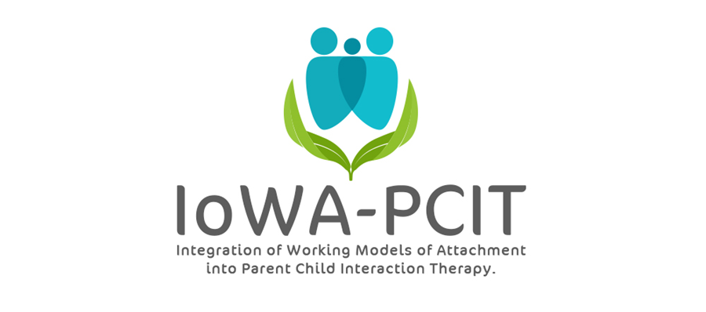

Description of training: This training will review the basics of IoWA-PCIT for therapists who have previously completed training in the model. The initial assessment, coding, and coaching challenges will be covered. Bring your questions!

About the trainer: Beth Troutman, Ph.D., ABPP has more than 35 years research, clinical, and training experience in infant and early childhood mental health. Dr. Troutman is the founder and creator of IoWA-PCIT, an adaptation of PCIT that incorporates attachment principles into PCIT to improve parent-child interactions and reduce disruptive behavior. Dr. Troutman’s research on attachment, infant mental health, and IoWA-PCIT has been published in peer-reviewed journals and presented at national and international meetings. Her book, Integrating Behaviorism and Attachment Theory in Parent Coaching, published by Springer in 2015, has been widely read by researchers and mental health providers. The Korean translation of this book was published by HAKIJSA in 2019. Her book, Attachment-Informed Parent Coaching, was published by Springer in 2022.
IoWA-PCIT Refresher
University of Iowa Carver College of Medicine
Psychiatry Research
Medical Education Building
Iowa City, IA 52242-1057
PLEASE PRINT LEGIBLY—THANK YOU!
Name:
Credentials (e.g. LISW, LMHC, MSW, PhD):
Organization:
Address:
City: State: Zip:
Day Phone: Fax:
Email:
REGISTRATION FEE: $200 per person | PAYMENT
- Includes:  - 1 all day session (9 AM to 4 PM) on July 22, 2022. | - Registration is complete when form and fees are received. Refunds will not be available for registered participants.  - Mail registration and payment (check or money order) to:  ATTN: Beth Troutman  1-182 Medical Education Building  Psychiatry Research  University of Iowa Carver College of Medicine  Iowa City, IA 52242-1057  - Check payable to:  University of Iowa
ONLINE TRAINING
All meetings will be held via ZOOM. ZOOM link will be provided following registration.
For questions contact Beth Troutman: 319-384-3236; beth-troutman@uiowa.edu
CEUS
Documentation of hours of attendance will be available. Full time attendance for the session (9 AM to 4 PM CST) is intended to meet the criteria for 6 hours of continuing education for Behavioral Science; Psychology; and Social Work.

