IoWA-PCIT Training Part I and II

ONLINE TRAINING

September 27 to October 1, 2021 (Part I)
March 7 to 9, 2022 (Part II)

Beth Troutman, PhD, ABPP

University of Iowa Carver College of Medicine
Iowa City, Iowa

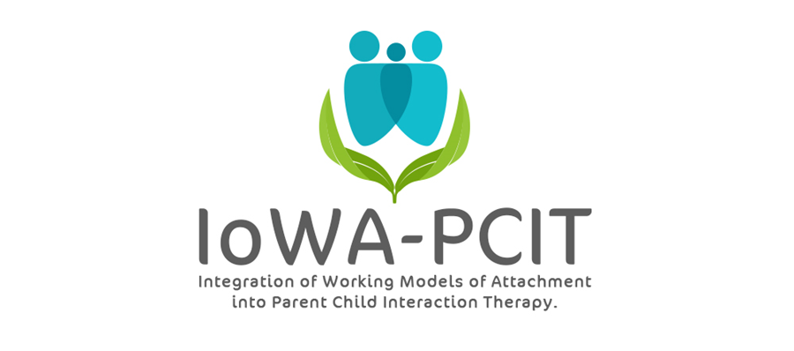

Description of training: This year long training provides mental health providers with the training and consultation needed to deliver IoWA-PCIT. Providers learn: 1) to administer and interpret standardized assessments of parent-child interaction based on attachment and behavioral principles; 2) to administer and interpret standardized assessments of disruptive behavior; 3) to coach parents in Child-Directed Interaction (CDI) and Parent-Directed Interaction (PDI). Providers begin delivering IoWA-PCIT following Part l training (September 28 to October 2, 2020). Monthly consultation calls and Part ll training (February 3 to 5, 2021) provides support for implementation of IoWA-PCIT and tailoring coaching based on attachment, presenting problem, and other aspects of patient population.

About the trainer: Beth Troutman, Ph.D., ABPP has more than 35 years research, clinical, and training experience in infant and early childhood mental health. Dr. Troutman is the founder and creator of IoWA-PCIT, an adaptation of PCIT that incorporates attachment and behavioral principles to improve parent-child interactions and reduce disruptive behavior. Dr. Troutman’s research on attachment, infant mental health, and IoWA-PCIT has been published in peer-reviewed journals and presented at national and international meetings. Her book, Integrating Behaviorism and Attachment Theory in Parent Coaching, published by Springer in 2015, has been widely read by researchers and mental health providers. The Korean translation of this book was published by HAKIJSA in 2019.
IoWA-PCIT Training Part l and ll
University of Iowa Carver College of Medicine
Psychiatry Research
Medical Education Building
Iowa City, IA 52242-1057
PLEASE PRINT LEGIBLY—THANK YOU!
Name:
Credentials (e.g. LISW, LMHC, MSW, PhD):
Organization:
Address:
City: State: Zip:
Day Phone: Fax:
Email:
REGISTRATION FEE: $4000 per person | PAYMENT
- Includes:  - 5 all day sessions on September 27, 28, 29, 30, and October 1, 2021; 3 all day sessions on March 7, 8, and 9, 2022; monthly consultation calls from September 2021 through September 2022.  - IoWA-PCIT manual  - Integrating Behaviorism and Attachment Theory in Parent Coaching book | - Registration is complete when form and fees are received. Refunds will not be available for registered participants.  - Mail registration and payment (check or money order) to:  ATTN: Beth Troutman  1-182 Medical Education Building  Psychiatry Research  University of Iowa Carver College of Medicine  Iowa City, IA 52242-1057  - Check payable to:  University of Iowa
ONLINE TRAINING
All meetings will be held via ZOOM. ZOOM link will be provided following registration.
For questions contact Beth Troutman: 319-384-3236; beth-troutman@uiowa.edu
CEUS
Documentation of hours of attendance will be available. Full time attendance for the 5 day session (part l) is intended to meet the criteria for 25 hours of continuing education for Behavioral Science; Psychology; and Social Work. Full time attendance for the 3 day session (part ll) is intended to meet the criteria for 15 hours of continuing education.

