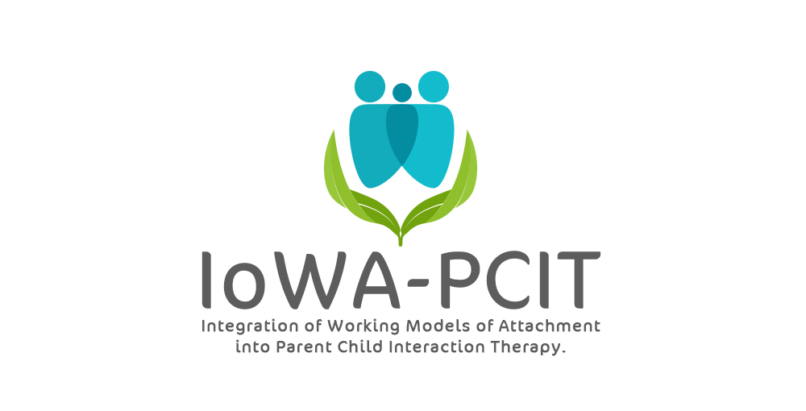CDI (Child-Directed Interaction) Teach & Engage
Caregiver Only Session
Goals:
- Establish parent buy-in by:
A) Finding out what the process of being observed and given instructions through the bug-in-the-ear was like for the parent
B) Helping parent see how PCIT will be useful to their specific child/family
C) Helping parent understand how coaching them during interactions will be helpful
D) Helping parent understand why the focus of PCIT is coaching them while interacting with their child rather than giving advice about behavior management

- Increase parent’s sense of hope and parenting self-efficacy
3) Help parent feel more comfortable with you and with the coaching process
4) Help parent become familiar with CDI skills

Activities:
- Administer Eyberg Child Behavior Inventory (ECBI)
- Discuss results of baseline assessment
- Give an overview of the structure of PCIT
- Review CDI skills
- Role-play CDI skills
- Give an overview of the structure of CDI sessions

Administer Eyberg Child Behavior Inventory (ECBI)
Inform the parent she/he will be completing the ECBI each week in order to track progress. Show the parent the graph we will be using to track their child’s progress.
Discuss results of baseline assessment
Some parents want to discuss the assessment in detail.
However, most parents just want to know:
1) whether you have figured out why their child acts the way they do
2) whether it is their fault
3) whether there is anything you can do to help them
If the child and parent seem appropriate for IoWA-PCIT, lead with this information. Tell them what you learned during the intake and baseline assessment that lets you know this was the appropriate intervention for their child/family. Tell them the types of problems observed or reported during the evaluation that you expect IoWA-PCIT will address and the types of improvements you expect to see.
If the child has been better behaved than usual during the observation (this is typical), talk about how the room and observation situation is specifically designed for children with disruptive behavior. Therefore, you are not likely to see the type of extreme behavior problems seen at home in the clinic. The goal of PCIT is to help learn what works in the clinic in order to get more of the type of positive behavior seen during the observation to occur at home and at school. (If the parent brings a tape of the child’s misbehavior they want you to watch, watch a brief (< 5 minutes) portion.) Talk about the types of child problems seen in the video that IoWA-PCIT will address. (Parents often have little insight into what the video reveals about their own behavior and reactions to their child.)
If child’s behavior was typical or worse than usual during the observation, talk about how IoWA-PCIT will address the types of behaviors seen during the observation.
Address any concerns the parent had about being observed or being given directions through the bug-in-the-ear.
Give an overview of the structure of IoWA-PCIT
Talk about how IoWA-PCIT will gradually introduce new ways of interacting with their child. Emphasis that they will learn to add new interaction patterns and that you will not be taking away any of their current strategies for managing their child’s behavior (as long as they are practicing safe discipline).
Tell them about the two phases of IoWA-PCIT: Child-Directed Interaction (CDI) and Parent-Directed Interaction (PDI)
Talk about how CDI is a special, therapeutic way of interacting with their child that they will be doing for 5 minutes a day once they have been coached in CDI. Explain that CDI is used to get the best possible behavior from their child during in-session IoWA-PCIT sessions. The 5 minutes a day CDI will help to generalize the positive behavior change to the home.
Review CDI skills (see CDI handout)
Emphasize how these skills are relevant to their child/family
When discussing management of misbehavior, review which of the presenting behavior problems could be considered dangerous or destructive and which of the presenting behavior problems could be considered annoying or obnoxious.
Use intake and initial observations to guide this discussion.
Role-play CDI skills
To familiarize the parent with the skills and get them used to the idea of being coached, role-play the skills with them.
Give an overview of the structure of CDI sessions
Explain to the parent what will happen at the next CDI coach session and subsequent CDI coach sessions.
1) They will complete the ECBI and give you a quick update on their week.
2) You will stay quiet and code behavior for 5 minutes while they do CDI with their child.
3) You will coach them through the bug-in-the-ear while they do CDI with their child.

