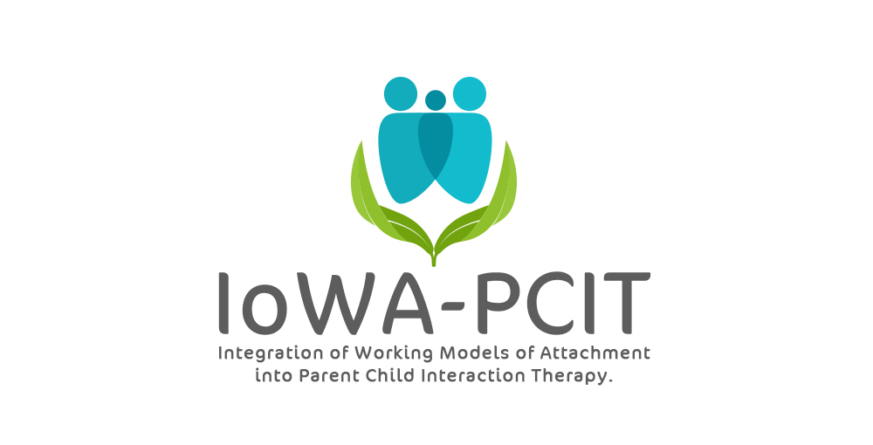CDI (Child-Directed Interaction) Coach Sessions
Goals:
- Increase caregiver’s mastery of CDI skills.
- Improve parent-child interaction
- Increase caregiver’s parenting self-efficacy by helping them see their positive impact on child
- Address behavior problems by coaching caregiver in attending to prosocial behavior and positive opposite of behavior problem
- Provide caregiver with the type of experience you want them to provide for their child. “Do unto others as you would have others do unto others.”
Activities:
- Check in with parent to see how the week has been (5 minutes or less) (beginning with the second CDI coaching session, review CDI homework)
- Administer Eyberg Child Behavior Inventory (ECBI)
- Code parent-child interactions for 5 minutes
- Coach parent-child interactions for 30 minutes (note: if 2 caregivers in treatment, coach each dyad for about 15 minutes)
- Show ECBI graph and CDI progress sheet to caregiver (as clinically indicated - this may be done every session or every few sessions)
- Assign CDI homework

Administer Eyberg Child Behavior Inventory (ECBI)
Remind the parent she/he will be completing the ECBI each week in order to track progress. Show the parent the graph we will be using to track their child’s progress.
Code parent-child interactions for 5 minutes
Coach parent-child interactions for 30 minutes
See code the coach CDI form for guidelines. Refer to Troutman (2015) for recommendations for coaching dyads with different patterns of attachment.
Show ECBI graph and CDI progress sheet to caregiver (as clinically indicated - this may be done every session or every few sessions)
Assign CDI homework
Problem-solve any difficulties with homework completion the previous week.
Continue with CDI coach sessions until:
Caregiver has met mastery criteria for CDI skills (i.e. 10 labeled praise, 10 reflections, and 10 behavior descriptions AND less than 3 commands, questions, or negative talk).
Improvement in parent-child relationship. (i.e. more balanced, secure attachment relationship)
NOTE: There is typically improvement in disruptive behavior (as indicated by ECBI ratings and parent report) during the CDI phase of treatment.

