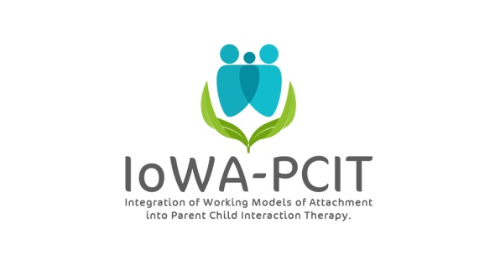PDI Skills Progress Summary
Child ____________________ Caregiver ______________________________
Session | Baseline (PLP at pre-treatment)
Date
Parent Commands
Direct Commands (DC)
Indirect Commands (IC)
NOC Commands
Child Compliance
Child complies with DC
Child complies with IC
Parent Response to Child Compliance to DC (within 2 statements)
Labeled praise
Unlabeled praise
Parent Response to Child Noncompliance to DC
Chair warning
Child Response to Warnings
Compliance
Noncompliance
Parent Response to Compliance after Warnings (within 2 statements)
Labeled praise
Unlabeled praise
% compliance
(child compliance/parent commands) * 100

