Advanced Training in Integrating Clinical Assessment of Attachment into PCIT Coaching

September 24 – 27, 2019

University of Iowa Carver College of Medicine
Iowa City, Iowa

Beth Troutman, Ph.D., ABPP

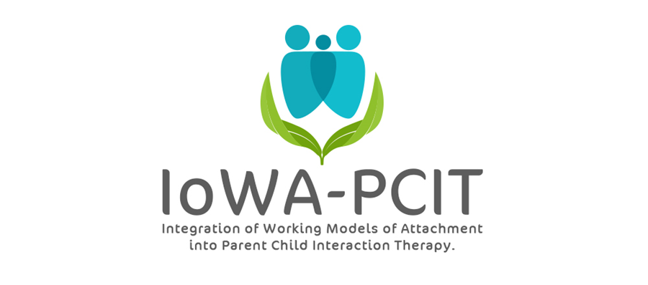

Description of workshop: This advanced workshop is limited to therapists who have previously been trained in PCIT and standardized assessment of attachment. Examples of training in standardized assessment of attachment include: completion of training in Integration of Working Models of Attachment into Parent Child Interaction Therapy (IoWA-PCIT), completion of research coding workshop for the Preschool Attachment Classification System (PACS), completion of 10 day Circle of Security workshop, or completion of University of Iowa Attachment Workshop for PCIT therapists.

This workshop will focus on interpreting clinical assessments of attachment, using observations of attachment to tailor PCIT coaching, communicating observations from clinical assessments of attachment, and using videofeedback with caregivers.

About the trainer: Beth Troutman, Ph.D., ABPP has been studying attachment theory for the past 30 years. Dr. Troutman’s training in attachment theory includes training in evidence-based attachment assessments and interventions at the University of Iowa, the University of Minnesota, the University of Amsterdam, the University of Quebec at Montreal, Tulane University, and Marycliff Institute. Her research on attachment and infant mental health has been published in peer-reviewed developmental and clinical journals and presented at national and international meetings.

Advanced Training in Integrating Clinical Assessment of Attachment into PCIT Coaching
University of Iowa Carver College of Medicine
Psychiatry Research
Medical Education Building
Iowa City, IA 52242-1057
PLEASE PRINT LEGIBLY—THANK YOU!
Name:
Credentials (e.g. LISW, LMHC, MSW, PhD):
Organization:
Address:
City: State: Zip:
Day Phone: Fax:
Email:
REGISTRATION FEE: $600 per person | PAYMENT
- Includes:  - Afternoon session on September 24, 2019 and 3 all day sessions on September 25, 26, and 27, 2019.  - Conference registration fees do not include lunch, accommodations, or parking. Arrangements for hotel accommodations are the responsibility of each individual participant. | - Registration is complete when form and fees are received. Refunds will not be available for registered participants.  - Mail registration and payment (check or money order) to:  ATTN: Beth Troutman  1-182 Medical Education Building  Psychiatry Research  University of Iowa Carver College of Medicine  Iowa City, IA 52242-1057  - Check payable to:  University of Iowa
MEETING LOCATION
All meetings will be held at the Medical Education Building at the University of Iowa.
For questions contact Beth Troutman: 319-384-3236; beth-troutman@uiowa.edu
CEUS
Documentation of hours of attendance will be available. Full time attendance for the 3 ½ day session is intended to meet the criteria for 28 hours of continuing education for Behavioral Science; Psychology; and Social Work. Sign-up sheets and information will be available on site.

